Laboratory Work 3
Active Directory Deployment
Ihor Zadorozhniak
Deployment platform: Oracle VirtualBox

Objective and report scope
The objective is to deploy the identity-lab.local Active Directory domain for Northstar Labs, configure DNS and directory objects, and prepare the environment for a later Keycloak LDAP integration. This report documents virtual machine preparation, network configuration and troubleshooting, and installation of the AD DS and DNS Server roles. Domain creation and validation will be documented as the work progresses.

1 Initial virtual machine inventory
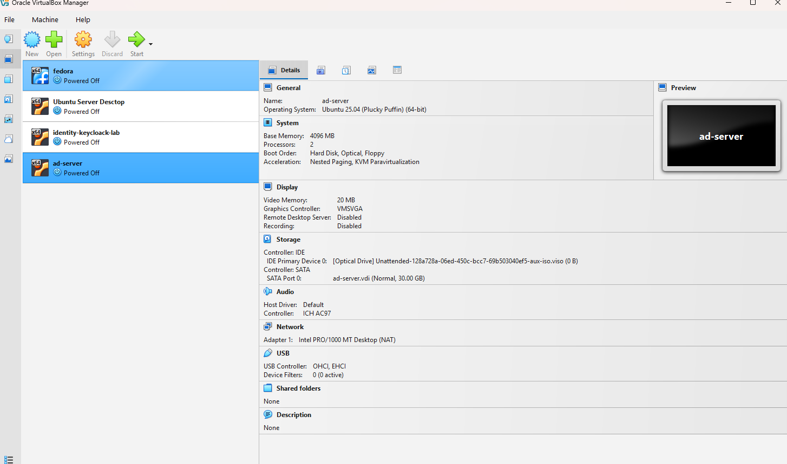
Figure 1. Initial VirtualBox environment
I reviewed the virtual machines available in VirtualBox, including identity-keycloak-lab and ad-server. At this stage, ad-server was powered off and its configured OS profile was Ubuntu 25.04, with 4096 MB RAM, two processors, and a 30 GB virtual disk; this screenshot records the initial inventory and does not confirm a Windows Server installation.

2 Host only network preparation
The laboratory uses a shared host-only network for communication between the virtual machines and the host computer. Each server also uses a NAT adapter for outbound internet access.
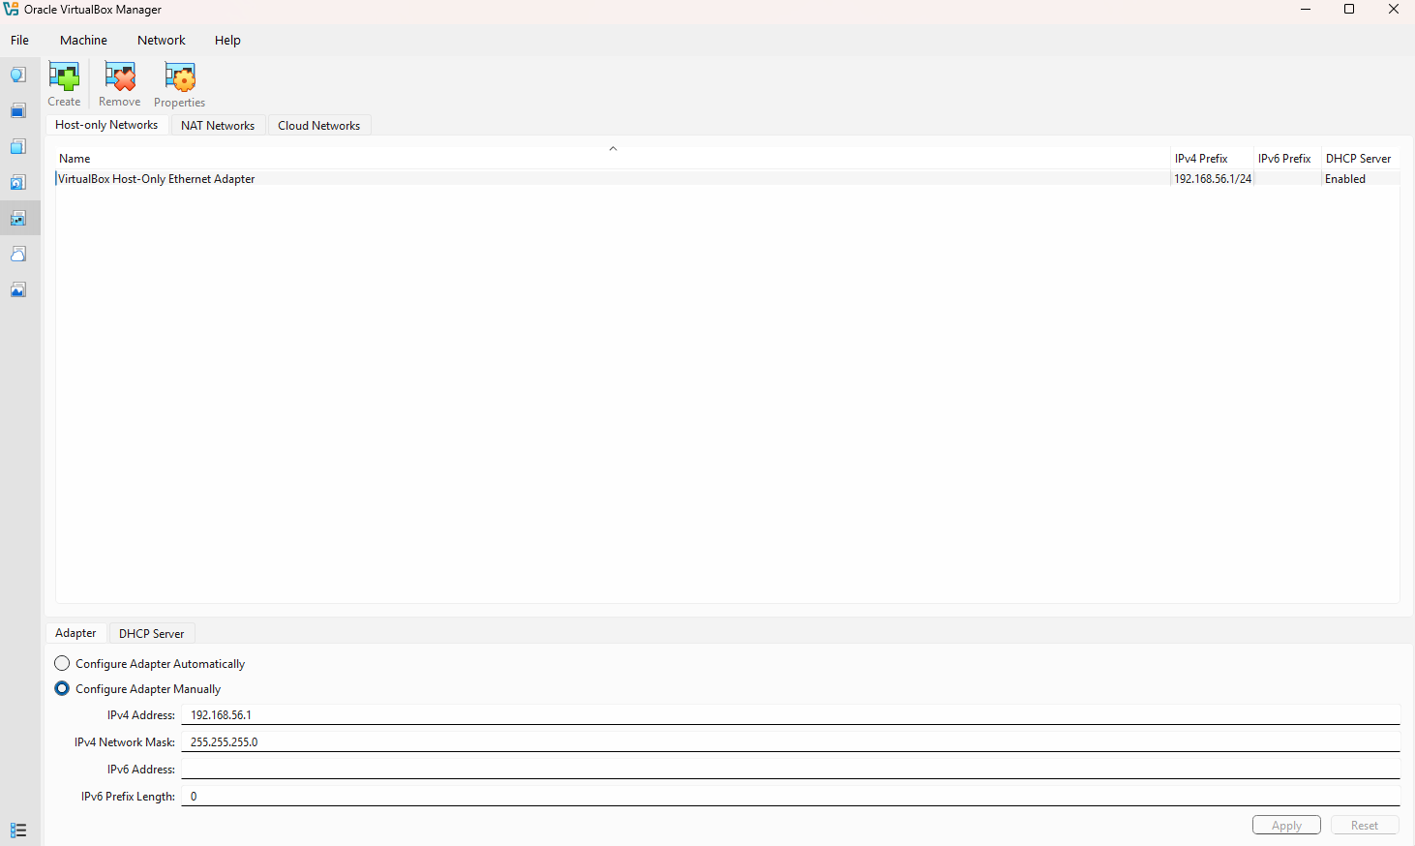
Figure 2. VirtualBox host-only network settings
I verified the VirtualBox Host-Only Ethernet Adapter with host address 192.168.56.1 and subnet mask 255.255.255.0. The network was present and DHCP was enabled, providing the shared 192.168.56.0/24 network required for the local laboratory.

3 Keycloak virtual machine adapters
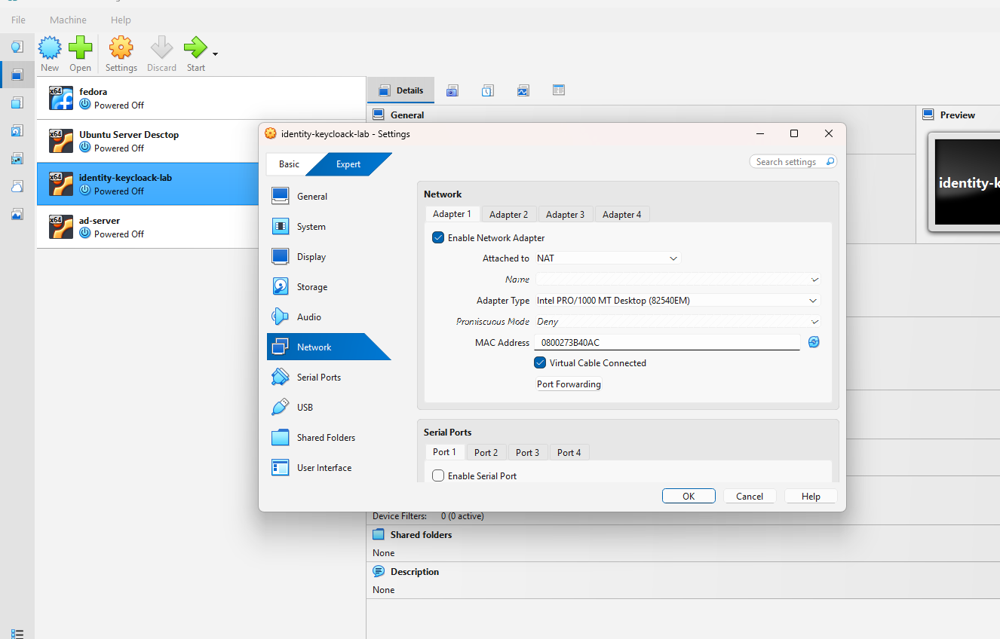
Figure 3. Keycloak Adapter 1 configured for NAT
I configured Adapter 1 of identity-keycloak-lab to use NAT and kept the virtual cable connected. The displayed settings confirm that the adapter was enabled for outbound internet connectivity.
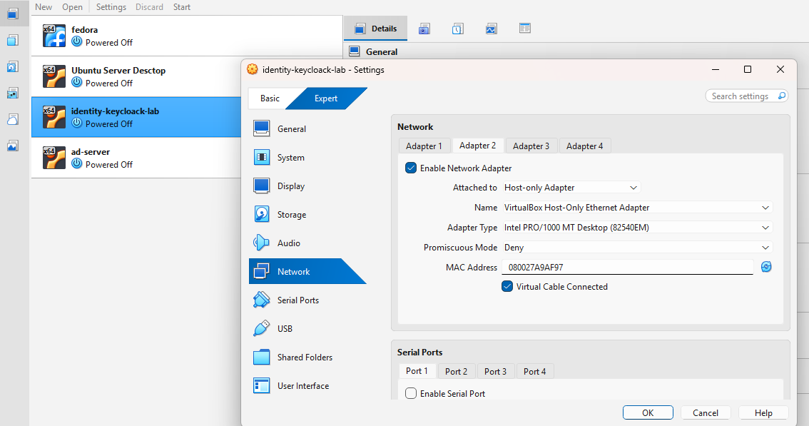
Figure 4. Keycloak Adapter 2 configured for the host-only network
I enabled Adapter 2 and attached it to the VirtualBox Host-Only Ethernet Adapter with the virtual cable connected. This connects the virtual hardware to the laboratory network; the guest operating system interface still requires configuration.

4 Keycloak guest network inspection
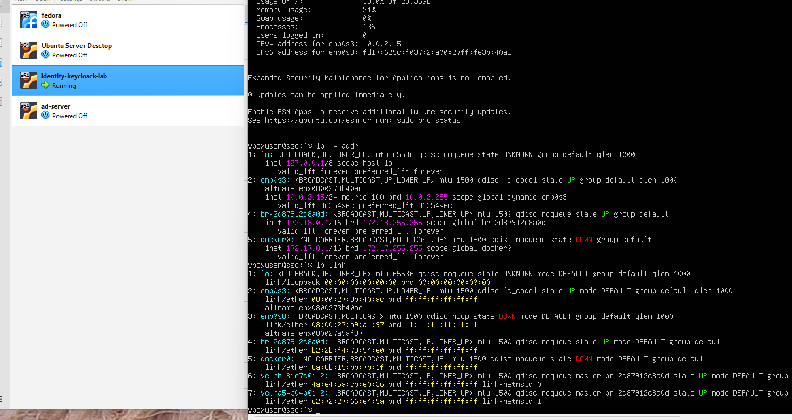
Figure 5. Ubuntu interface and IPv4 address inspection
I ran ip -4 addr and ip link to inspect the Keycloak VM network interfaces. The NAT interface enp0s3 was UP with address 10.0.2.15/24, while enp0s8 was DOWN and had no displayed IPv4 address, so host-only connectivity was not yet established.
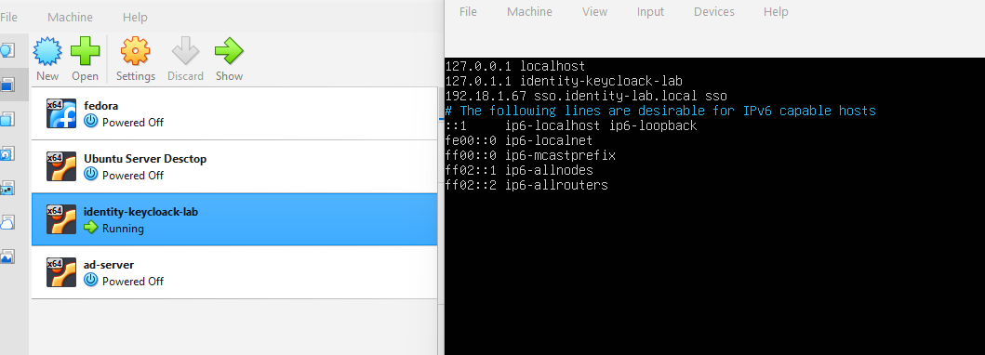
Figure 6. Existing local hostname mapping
I inspected /etc/hosts and found the entry 192.18.1.67 sso.identity-lab.local sso. This address differs from the planned host-only subnet, so the mapping needs to be updated after the Keycloak host-only address is configured.

5 Windows Server virtual machine network settings
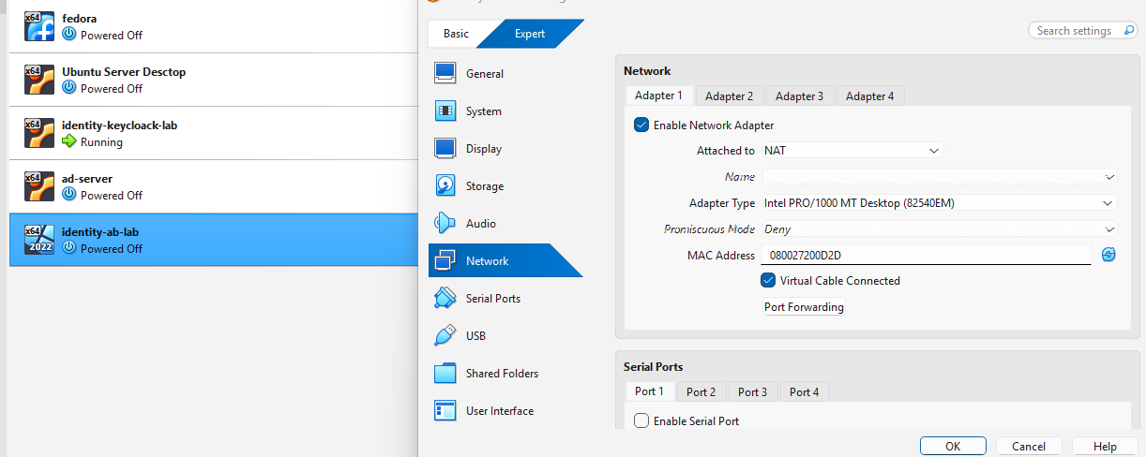
Figure 7. NAT adapter for identity-ab-lab
I configured Adapter 1 of the newly listed identity-ab-lab virtual machine to use NAT with the virtual cable connected. The VM was powered off, and this screenshot confirms its adapter settings rather than completion of the Windows Server installation.
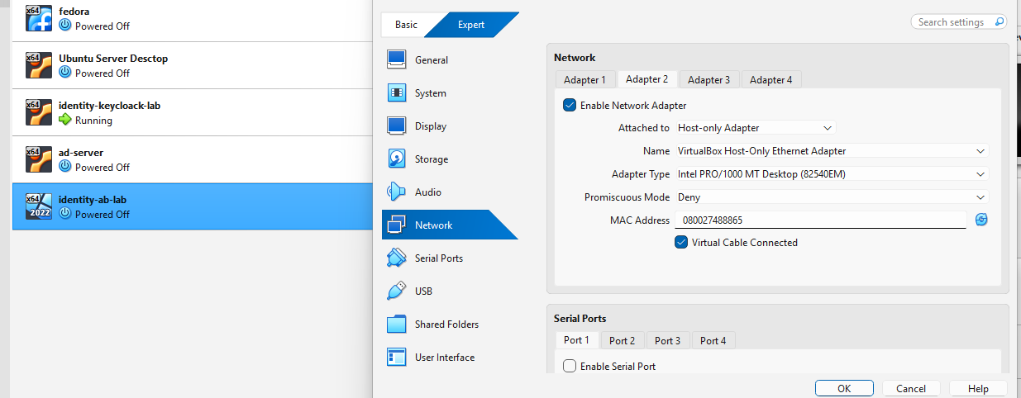
Figure 8. Host-only adapter for identity-ab-lab
I enabled Adapter 2 and selected the same VirtualBox Host-Only Ethernet Adapter used by the Keycloak VM. Both virtual machines now have matching host-only adapter selections, while guest IP configuration and communication tests remain to be documented.

6 Windows network and connectivity checks
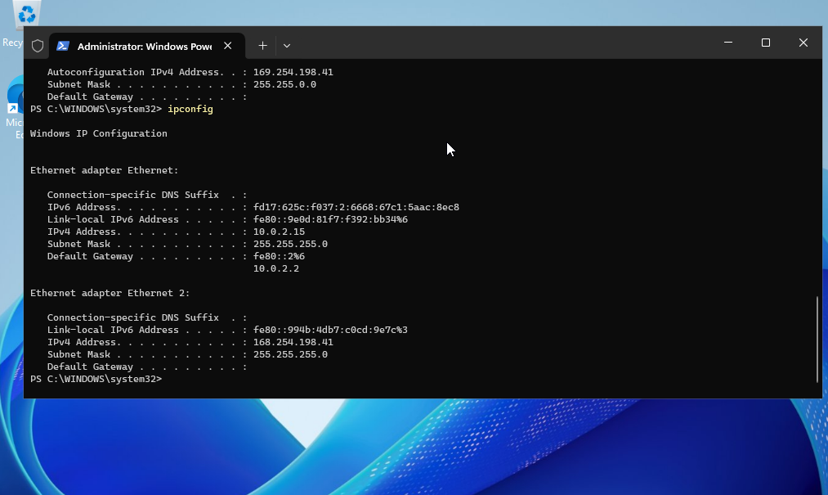
Figure 9. Windows IPv4 configuration inspection
I ran ipconfig in an elevated PowerShell window to inspect the Windows network configuration. Ethernet used 10.0.2.15/24 with gateway 10.0.2.2, while Ethernet 2 displayed 168.254.198.41/24 without a default gateway. The second adapter address was outside the intended 192.168.56.0/24 host-only subnet, so its configuration still needed correction.
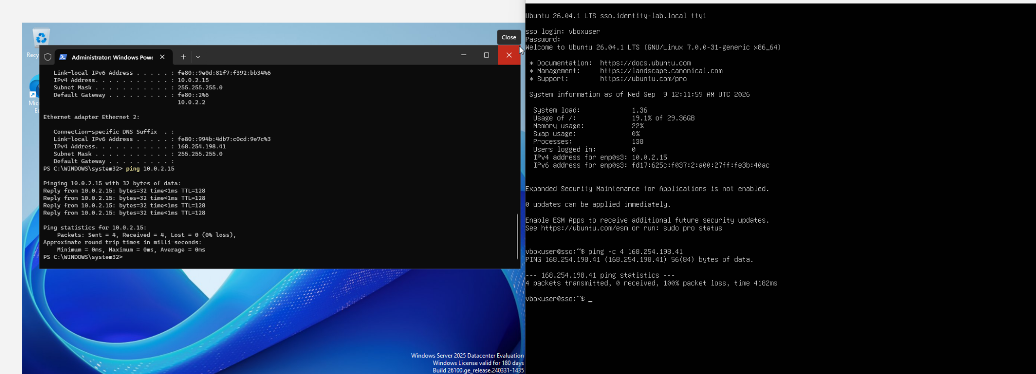
Figure 10. Initial ping tests on Windows Server and Ubuntu
I ran ping 10.0.2.15 on Windows Server 2025 Datacenter Evaluation and ping -c 4 168.254.198.41 on the Ubuntu Keycloak VM. Windows received four replies from its own NAT address, while Ubuntu received no replies and reported 100% packet loss. These results did not establish connectivity between the two VMs, so further host-only network configuration was required.

7 Host only network verification during troubleshooting
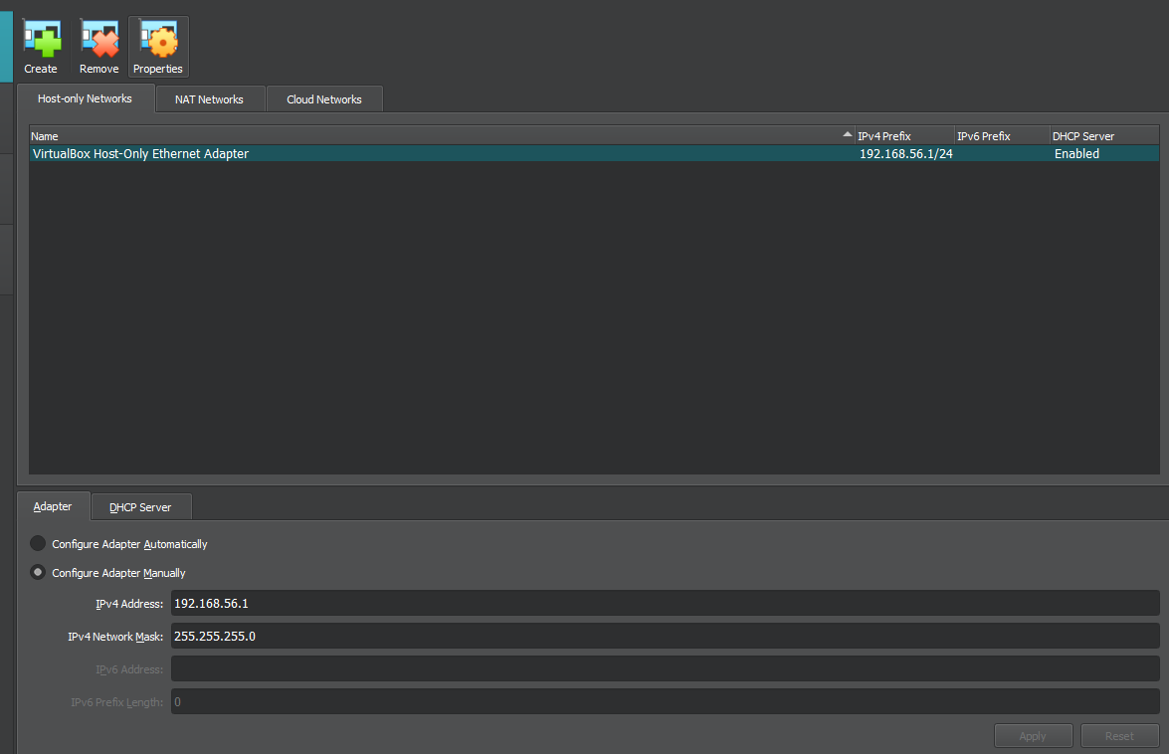
Figure 11. Rechecking the VirtualBox host-only subnet
I reopened VirtualBox Network Manager and verified that the host-only adapter used 192.168.56.1 with subnet mask 255.255.255.0 and DHCP enabled. This confirmed the intended 192.168.56.0/24 subnet and highlighted the mismatch with the Windows Ethernet 2 address shown in Figure 9.

8 Keycloak interface and routing inspection
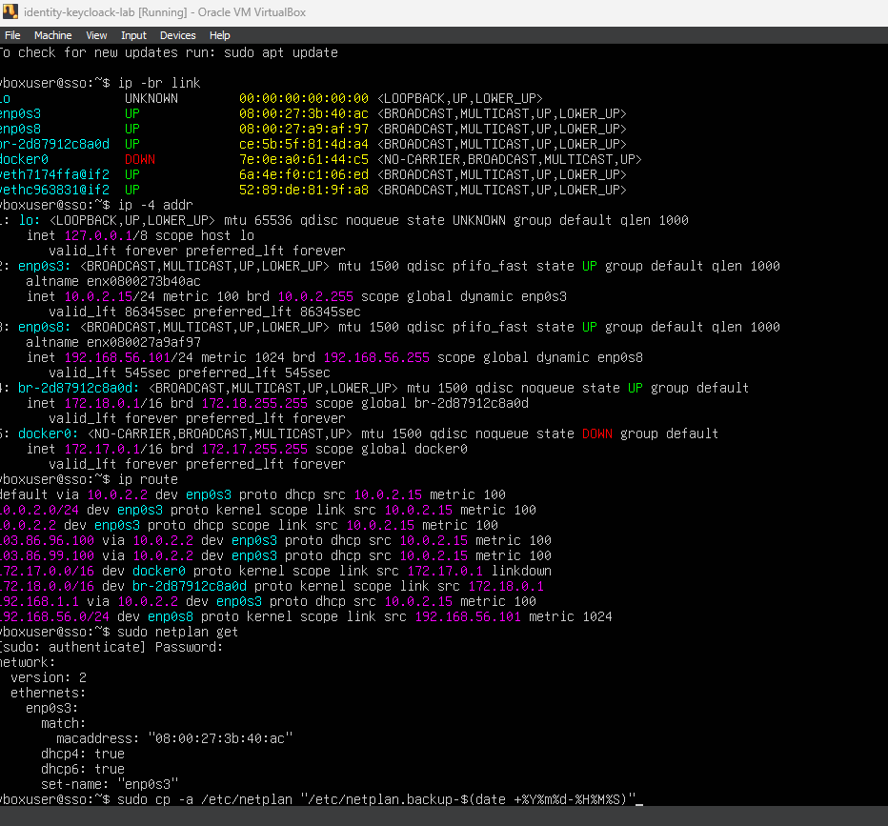
Figure 12. Inspecting active interfaces and the existing Netplan configuration
I inspected the interfaces, IPv4 addresses, routing table, and Netplan configuration using ip -br link, ip -4 addr, ip route, and sudo netplan get. The host-only interface enp0s8 was now UP with the dynamic address 192.168.56.101/24, while the default route remained through the NAT interface enp0s3. The displayed Netplan configuration listed only enp0s3, so a persistent static configuration for enp0s8 was still needed.

9 Static address configuration for Keycloak
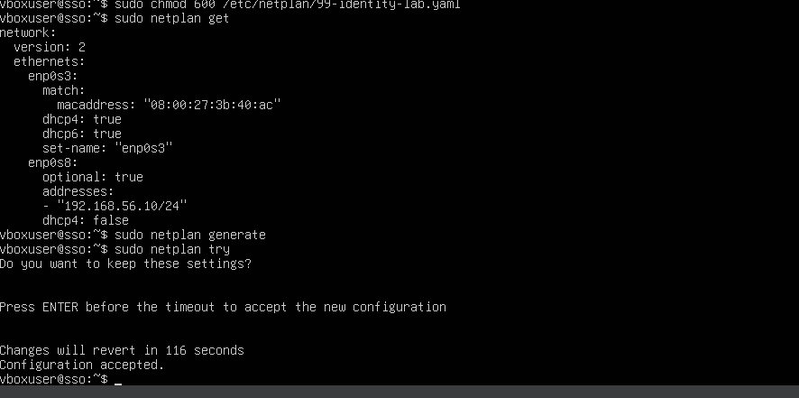
Figure 13. Applying and accepting the Netplan configuration
I set the permissions of /etc/netplan/99-identity-lab.yaml to 600 and verified that Netplan configured enp0s8 with 192.168.56.10/24, dhcp4 disabled, and optional enabled, while retaining DHCP on enp0s3. I ran sudo netplan generate and sudo netplan try, then accepted the new settings. The terminal reported Configuration accepted, confirming acceptance of the network configuration.
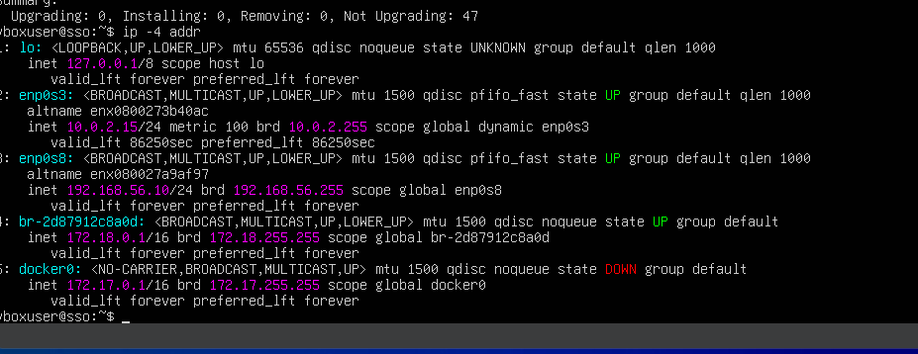
Figure 14. Verifying the static host-only IPv4 address
I ran ip -4 addr after applying the Netplan configuration. The output confirmed that enp0s8 was UP with 192.168.56.10/24 and unlimited address lifetimes, while enp0s3 retained its dynamic NAT address of 10.0.2.15/24. The Keycloak host-only address was therefore configured as planned.

10 Windows Server name and adapter verification
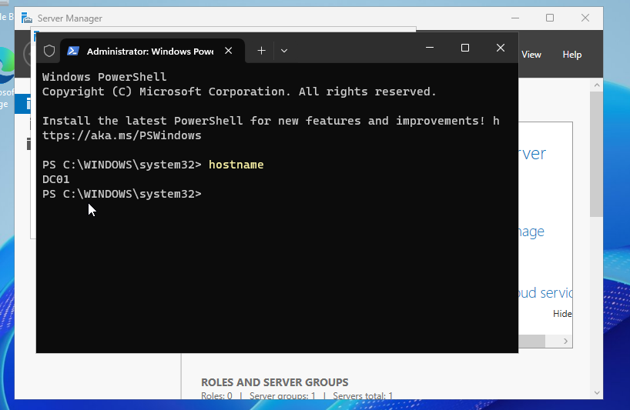
Figure 15. Verifying the Windows Server hostname
I ran hostname in an elevated PowerShell window to verify the server name. The command returned DC01, confirming that the Windows Server computer name matched the laboratory requirement.
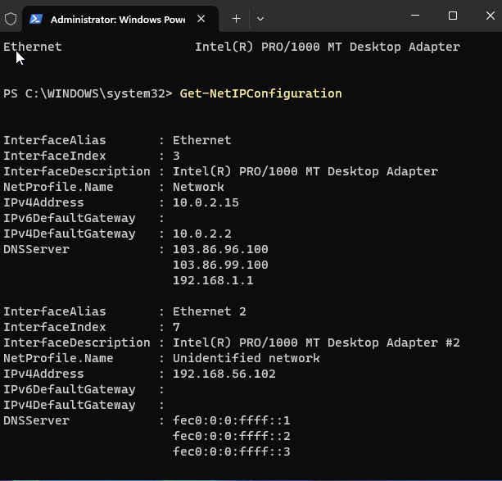
Figure 16. Inspecting Windows network adapters before static addressing
I ran Get-NetIPConfiguration to inspect both Windows network interfaces. Ethernet used the NAT address 10.0.2.15 with gateway 10.0.2.2, while Ethernet 2 used 192.168.56.102 without an IPv4 default gateway. The host-only adapter was now in the intended subnet, but its planned static address and DNS settings still needed to be applied.

11 Static server addressing and successful connectivity
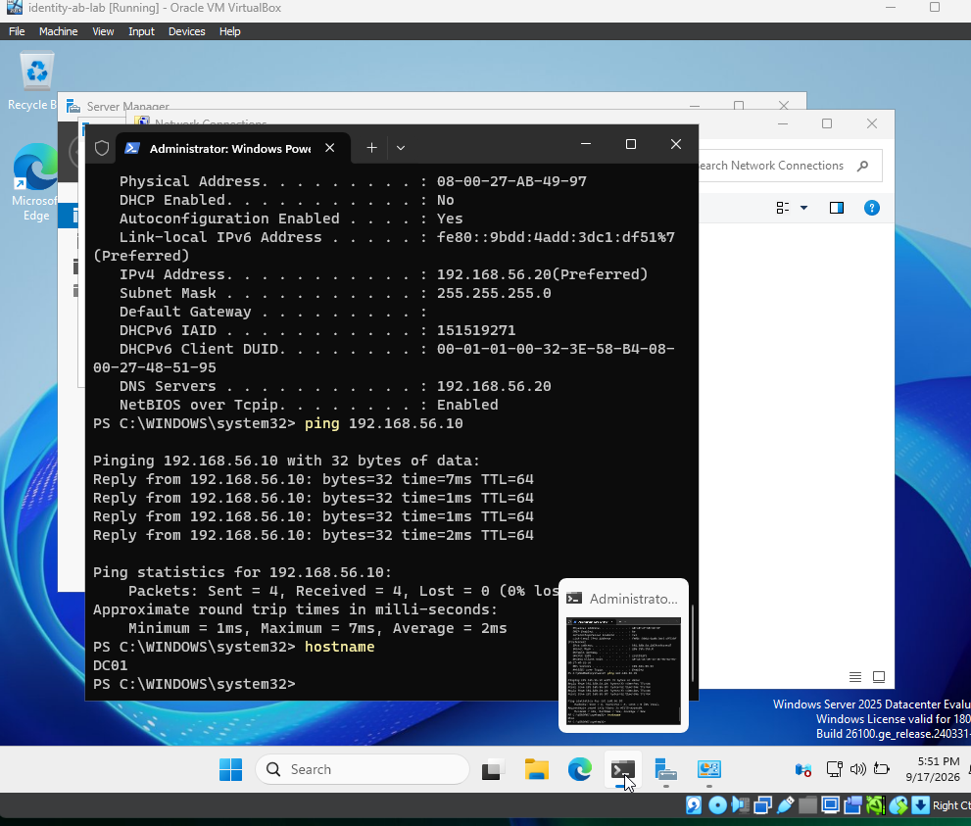
Figure 17. Confirming the static server address and ping to Keycloak
I configured the Windows host-only adapter with static IPv4 address 192.168.56.20, subnet mask 255.255.255.0, and DNS server 192.168.56.20, leaving the default gateway blank; the displayed configuration confirmed that DHCP was disabled. I then ran ping 192.168.56.10 and received four replies with 0% packet loss, confirming connectivity from Windows Server to the Keycloak VM. A subsequent hostname command returned DC01.

12 Installation of AD DS and DNS Server roles
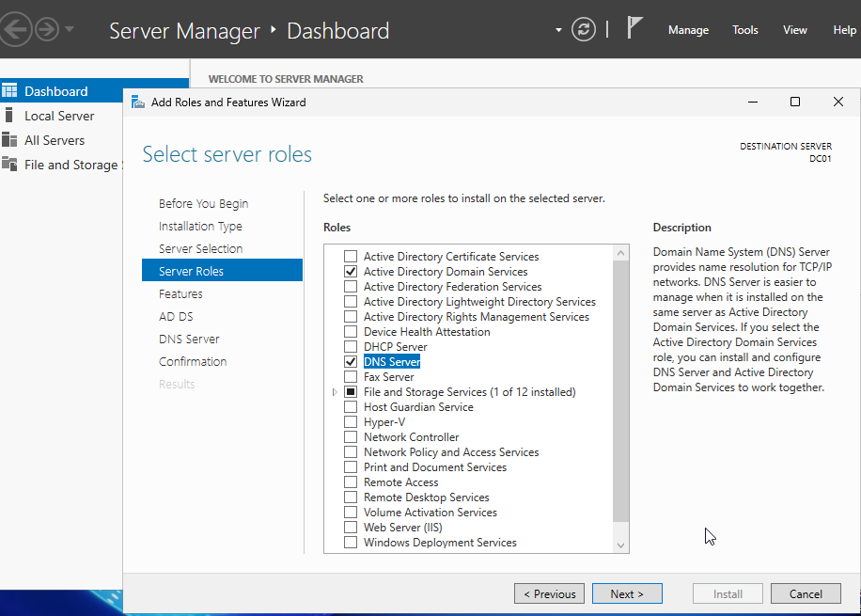
Figure 18. Selecting AD DS and DNS Server on DC01
I opened the Add Roles and Features Wizard in Server Manager and selected Active Directory Domain Services and DNS Server for DC01. Both roles were checked on the Server Roles page, preparing the required components for installation.
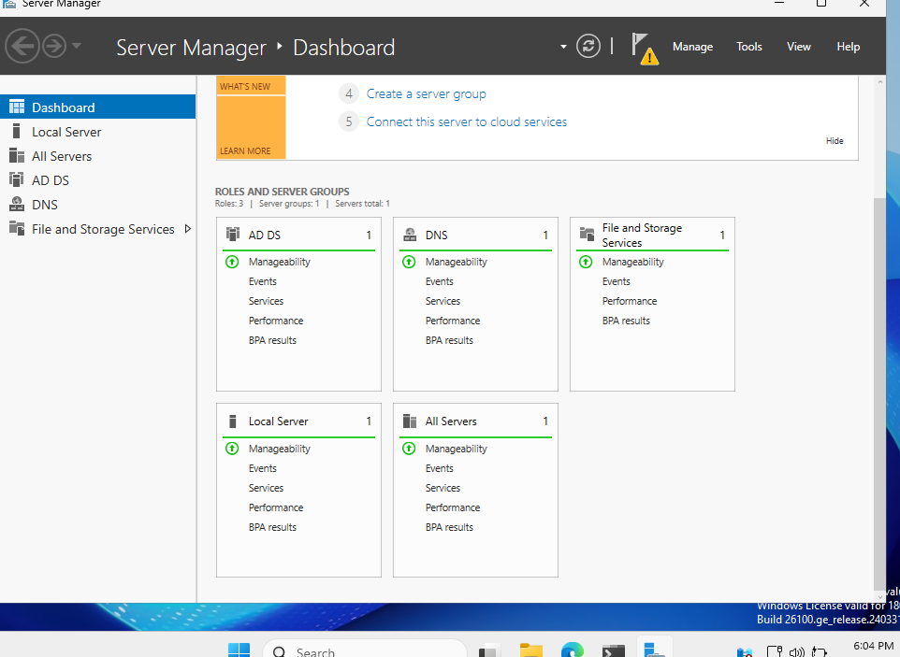
Figure 19. Verifying the installed roles in Server Manager
After installing the selected roles, I verified that AD DS and DNS appeared in the Server Manager navigation pane and dashboard. Both role tiles displayed green manageability indicators, and a notification flag remained visible. The roles were available for configuration, while promotion to a domain controller and creation of identity-lab.local still needed to be documented.



